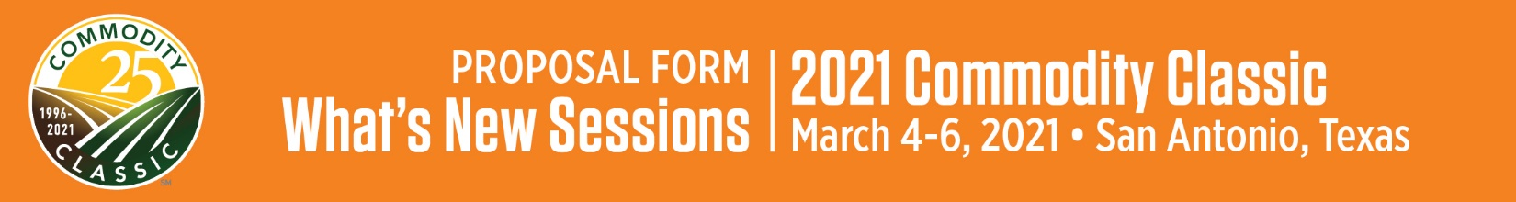
Reminder: Company must be a current 2021 Commodity Classic exhibitor to sponsor a What’s New Session.
What’s New Sponsor Company (for printed materials & website):

Proposed What’s New Session Title:

Proposed What’s New Description (35-40 words) for Commodity Classic printed materials & website (Updates may be made prior to publication):

Explain the product/service in detail, specifying how it impacts farming. How is this new?

Proposed What’s New Session Outline:

Date to be introduced to market:
To be introduced at Commodity Classic? | YES | NO

What’s New Presenters’ Names & Titles*:
*Due December 18, 2020.
Sponsorship fee: $8,500 per 40-minute session
Would you like additional promotion of your What’s New Session for $500? | YES | NO

Planning Contact:
Name: |  | Company: |  | Email: |  | Phone:

Company Contact (if different than Planning Contact):
Name: |  | Company: |  | Email: |  | Phone:

Billing Contact:
Name |  | Phone
Title |  | E-mail
Company
Address
City, State |  | Zip

NOTE: Exchange of payment for products/services during What’s New Sessions is strictly prohibited.
Sponsors and speakers must return a signed copy of the Commodity Classic Presentation Recording and Use Policy. Commodity Classic and its designated vendors shall have exclusive rights to professionally video and audio recorded sessions unless otherwise agreed.
Commodity Classic will provide a professional recording to be used as the sponsor wishes. Use of this recording must carry the Commodity Classic brand/logo and attribute the recording’s origin, i.e. “Taped at 2021 Commodity Classic, March 4-6, 2021 in San Antonio, Texas.” When the recording is used in whole, the Commodity Classic branding must be kept intact. If not used in whole, the sponsor has permission to remove the Commodity Classic branding but must attribute the clip to Commodity Classic, , i.e. “Taped at 2021 Commodity Classic.” Sponsors may use the professional recording provided to them by Commodity Classic, provided they comply with the terms of this policy.
REFUND POLICY: Please note that once Commodity Classic sponsorships are confirmed, they are non-cancelable and non-transferable. Commodity Classic also reserves the right to modify or cancel sponsored events upon notice to sponsors and pro rata adjustment to or refund of sponsorship fees.
Proposals must be submitted by Friday, October 16, 2020 to:
Abby Podkul  Director, Meetings & Conventions and Education Lead, Commodity Classic  American Soybean Association | apodkul@soy.org | O: 314-754-1345 C: 314-517-5971

