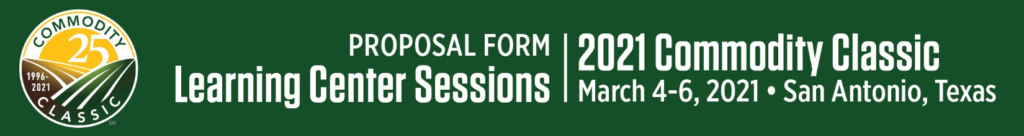
Reminder: Company must be a current 2021 Commodity Classic exhibitor to sponsor a Learning Center Session.
Proposed Learning Center Title:

Describe your proposed Learning Center Session for Commodity Classic printed materials & website in roughly 100 words, in a way that will make farmer attendees want to come to your session. (Updates may be made prior to publication):

Provide more details about the topic or your proposed session, if needed.

Learning Center Speakers*, Potential Speakers or Type of Speakers:
Name |  | Title |  | Company
Name |  | Title |  | Company
Name |  | Title |  | Company
Name |  | Title |  | Company
Name |  | Title |  | Company
*Speaker names are preferred to help the committee to qualify the session. If names are not available, please list potential speakers or type of speakers.
Speaker Biographies:

Key Benefits to those who attend:

Subject Matter of Session:

American Society of Agronomy CEU category (check one):
- Nutrient Management
- Soil & Water Management
- Integrated Pest Management
- Crop Management
- Professional Development
- Precision Ag
- Sustainability
For which Learning Center format are you applying? (You may choose more than one if you are open to the format being chosen by the Commodity Classic Committee).
Learning Center (75 minutes) | $10,000* | YES | NO
Learning Center (60 minutes) | $5,000* | YES | NO
Early Riser Session (60 minutes) | $12,500* | YES | NO
Closing Learning Center (75 – 120 minutes) | $12,500* | YES | NO
Main Stage Presentation (45 minutes) | $12,500* | YES | NO
Roundtable Discussions (45-60 minutes) | Call for pricing* | YES | NO
*Plus speaker expenses (travel, housing, meals, etc.)
Would you like additional promotion of your Learning Center Session for $500? | YES | NO

If you are submitting more than one Learning Center proposal, how many are your company willing to sponsor if more than one is selected?

Learning Center Sponsor Company for Commodity Classic printed materials & website:

Planning/On-Site Logistical Contact:
Name: |  | Company: |  | Email: |  | Phone:

Company Contact (if different than Planning Contact):
Name: |  | Company: |  | Email: |  | Phone:

Billing Contact:
Name |  | Phone
Title |  | E-mail
Company
Address
City, State |  | Zip

NOTE: Exchange of payment for products/services during Learning Center Sessions is strictly prohibited.
Sponsors and speakers must return a signed copy of the Commodity Classic Presentation Recording and Use Policy. Commodity Classic and its designated vendors shall have exclusive rights to professionally video and audio recorded sessions unless otherwise agreed.
Commodity Classic will provide a professional recording for all non-Main Stage Learning Centers to be used as the sponsor wishes. Use of this recording must carry the Commodity Classic brand/logo and attribute the recording’s origin, i.e. “Taped at 2021 Commodity Classic, March 4-6, 2021 in San Antonio, Texas.” When the recording is used in whole, the Commodity Classic branding must be kept intact. If not used in whole, the sponsor has permission to remove the Commodity Classic branding but must attribute the clip to Commodity Classic,, i.e. “Taped at 2021 Commodity Classic.” Sponsors may use the professional recording provided to them by Commodity Classic, provided they comply with the terms of this policy.
REFUND POLICY: Please note that once Commodity Classic sponsorships are confirmed, they are non-cancelable and non-transferable. Commodity Classic also reserves the right to modify or cancel sponsored events upon notice to sponsors and pro rata adjustment to or refund of sponsorship fees.
Proposals must be submitted by Tuesday, June 30, 2020 to:
Abby Podkul  Director, Meetings & Conventions and Education Lead, Commodity Classic  American Soybean Association | apodkul@soy.org | O: 314-754-1345 C: 314-517-5971

