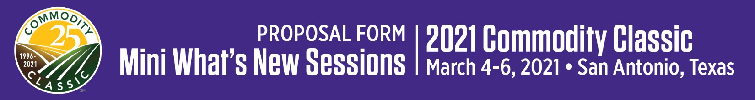
Reminder: Company must be a current 2021 Commodity Classic exhibitor to present a Mini What’s New Session.

Mini What’s New Sponsoring Company (for printed materials & website):

Proposed Mini What’s New Session Title (for printed materials & website):

Explain the product/service in detail, specifying how it impacts farming. How is this new?

Date to be introduced to market:
To be introduced at Commodity Classic? |  | YES | NO

Mini What’s New Presenter’s
Name & Title*:
*Due December 18, 2020.
Planning Contact:
Name: |  | Company: |  | Email: |  | Phone:

Company Contact (if different than Planning Contact):
Name: |  | Company: |  | Email: |  | Phone:

Billing Contact:
Name |  | Phone
Title |  | E-mail
Company
Address
City, State |  | Zip

Sponsorship fee: $1,500.00 for 5-minute session plus repeat 5-minute session
NOTE: Exchange of payment for products/services during Mini What’s New Sessions is strictly prohibited.
Commodity Classic and its designated vendors shall have exclusive rights to record sessions unless otherwise agreed.
REFUND POLICY: Please note that once Commodity Classic sponsorships are confirmed, they are non-cancelable and non-transferable. Commodity Classic also reserves the right to modify or cancel sponsored events upon notice to sponsors and pro rata adjustment to or refund of sponsorship fees.

Proposals must be submitted by Friday, October 16, 2020 to:
Abby Podkul  Director, Meetings & Conventions and Education Lead, Commodity Classic  American Soybean Association | apodkul@soy.org | O: 314-754-1345 C: 314-517-5971

